|  |  |
| --- | --- |
|  | FPT ACADEMY INTERNATIONAL  FPT – APTECH COMPUTER EDUCATION |

Centre Name: ACE-HCMC-2-FPT.

Address: 590 Cach Mang Thang 8, District 3, Ho Chi Minh City, Viet Nam.

**[FotoLab]**

|  |  |  |
| --- | --- | --- |
| Supervisor: | Phạm Thị Lánh | |
| Term: | 1 | |
| Batch No: | T1.2208.M0 | |
| Group No: | 5 | |
| Order: | Full name | Roll No. |
| 1. | Trần Thiện Hiếu | Student1394598 |
| 2. | Võ Thị Yến Nhi | Student1405198 |
| 3. | Lê Thanh Sơn | Student1398803 |
| 4. | Nguyễn Thái Thanh | Student1387834 |

Month 10 Year 2022

This is to certify that

**Mr. TRẦN THIỆN HIẾU**

**Ms. VÕ THỊ YẾN NHI**

**Mr. LÊ THANH SƠN**

**Mr. NGUYỄN THÁI THANH**

Have successfully Designed & Developed

**FOTOLAB**

Submitted by: **Ms. PHAM THI LANH**

Date Of Issue: October, 2022

Authorized Signature:

# Content

Content 3

Acknowledge 5

Synopsis 6

REVIEW 1 7

Problem Definition 8

Customer Requirements Specifications 9

Architecture and Design of the project 10

Site map 11

Website design layout 12

I. Homepage 12

II. Sign in 13

III. Sign up 14

IV. Product 15

V. Product Comparison 16

VI. Product Detail 17

VII. User’s Cart 18

VIII. Buy Now Page 19

IX. Contact 20

X. About Us 21

Task Sheet 22

REVIEW 2 23

WEBSITE USER INTERFACE 24

I. Homepage 24

II. Sign In/ Sign Up dropdown 26

III. Register Page 27

IV. Product Page 28

V. Product Category/Search Dropdown 29

VI. Product Comparison 30

VII. Product Detail 31

VIII. Cart Page 32

IX. Buy Now Page 33

X. Contact 34

XI. About 36

Task Sheet 37

Testing document 38

Final checklist 39

# Acknowledge

As we understand that the eProject is a step-by-step learning environment that closely simulates the classroom and Lab based learning environment into actual implementation. It is a project implementation at your fingertips!! An electronic, live juncture on the machine that allows you to.

✓ Practice step by step i.e., laddered approach.

✓ Build a larger, more robust application.

✓ Usage of certain utilities in applications designed by the user.

✓ Single program to unified code leading to a complete application.

✓ Learn implementation of concepts in a phased manner.

✓ Enhance skills and add value.

✓ Work on real life projects.

✓ Give a real-life scenario and help to create applications more complicated and useful.

✓ Mentoring through email support.

We would like to send a great thank to our professor and others student for the adorable support during the time in the project.

Beside several mistakes we had made in the project, we hope to have more opportunities to widen our knowledge in the web developing world.

We also thank you so much for your information and the “demo” project from India APTECH to help us get more reality experience in this project. Since we have gained more experience from this project, we will not stop learning anything as much as we can to be more successful in the future.

Your Sincerely,

Team Group 05.

# Synopsis

- The Objective of this program we aim is to give a sample project to work on real life projects. These applications help us build a larger, more robust application.

- The objective is not to teach us HTML/JavaScript but to provide us with a real life scenario and help us create basic applications using the tools.

- Hence, we can revise the chapters before we start with the project.

- This project The Objective of this program is to give a sample project to work on real life projects. These applications help you build a larger, more robust application.

- The objective is not to teach you the software but to provide you with a real-life scenario and help you create basic applications using the tools.

- You can revise the topics before you start with the project.

- This project is meant for students who have completed the module of Dreamweaver.

- These programs should be done in the Lab sessions with assistance of the faculty if required.

- The website (in this project) is a tool that help the company to access the

e-commercial market and gain more and more new customers.

- It is very essential that a student has a clear understanding of the subject.

# REVIEW 1

## Problem Definition

FOTOLAB was established in 1991 with the objective of providing sales service for Digital Camera, SLR Camera, Handycam, their accessories and all other related products.

They allot top priority to innovation & upgradation of technology in the avenues of Distribution of All kinds and brands of Digital Camera and their related accessories.

The customers get the benefit of Undivided Attention, Expert Analysis, Innovative Ideas, Commitment and Comprehensive Hardware & Software Solution.

Hence, they need a new website to solve all their above demands.

The website is to be developed for the Windows Platform using HTML5, JavaScript and Geolocation. The site should work well in all leading browsers including Chrome, IE, Firefox etc.

Here are some problems need to be resolved:

1. With the developing technology, lead to change customer’s shopping habit, more and more customers are interested in shopping online. Hence, FotoLab want develop a new independence website, only serve customers’s online camera shopping and purchase the right product that meets theirs needs.

2. With many experience-years in providing photograph services, customer will receive good advises from our experts. hence, customers can avoid to wastage of time and costs.

3. Online customers have an interest in reading reviews before purchasing specific products.

4. To approaching various type of customer, our website's layout, framework and display need to be easy to manipulate, suitable and friendly with all ages, generations and levels. Everyone can discover and purchase on this.

## Customer Requirements Specifications

|  |
| --- |
| USER: |
| Input:  ● Input consumer’s address of residence or office  ● Send questions/requests to the company |
| Process:  ● Process consumer’s address data  ● Collect questions/requests sent by consumers |
| Output:  ● Show the store address to consumers  ● Reply to the consumer’s requests/questions |

|  |
| --- |
| WEBMASTER: |
| Input:  ● Control website database, input product information,… |
| Process:  ● Analyse website |
| Output:  ● Website interface, images, forms, …  ● Giving interaction |

|  |
| --- |
| HARDWARE / SOFTWARE REQUIREMENT: |
| Software:  ● Notepad/HTML editor  ● Dreamweaver/Javascript |
| Hardware:  ● A minimum computer system that will help you access all the tools in the courses is a Pentium 166 or better  ● 64 Megabytes of RAM or better |

## Architecture and Design of the project

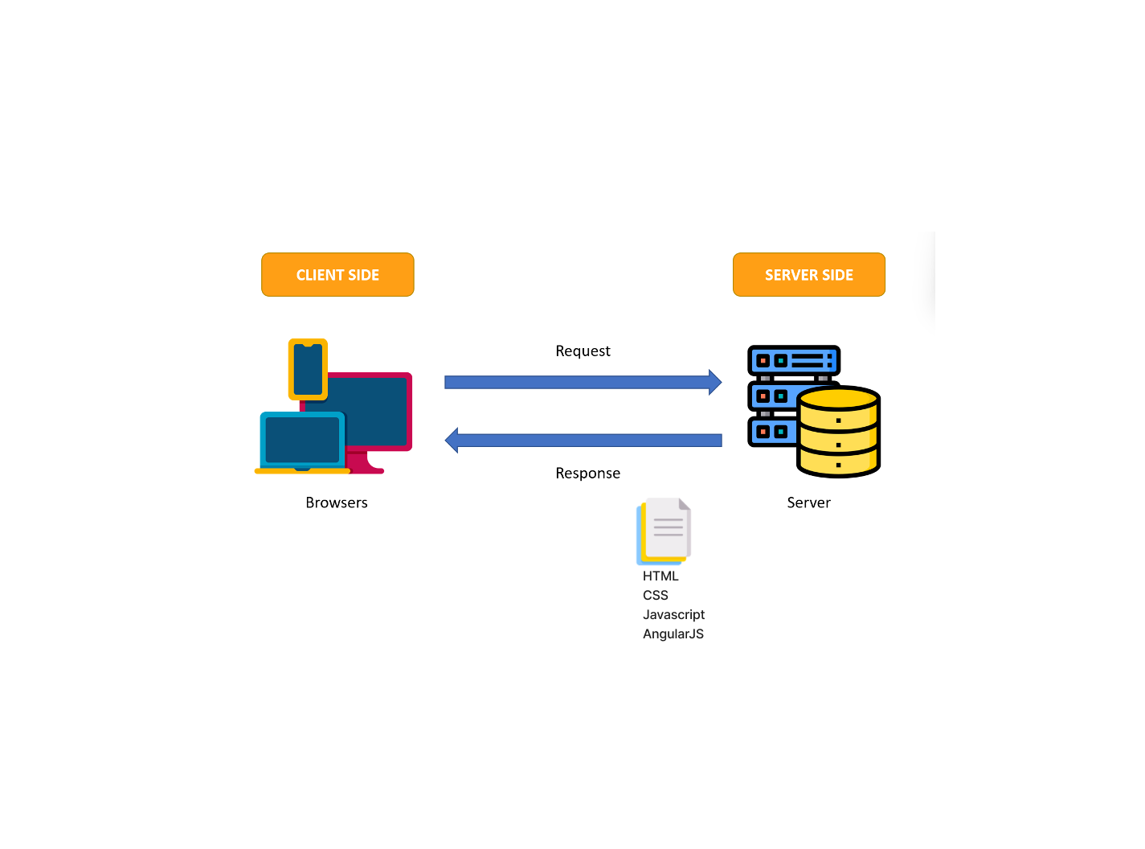

## Site map

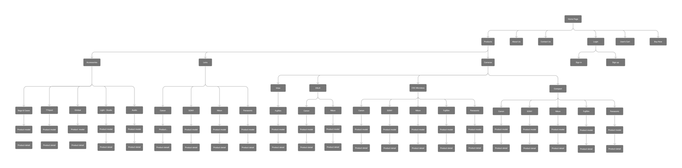

## Website design layout

### Homepage

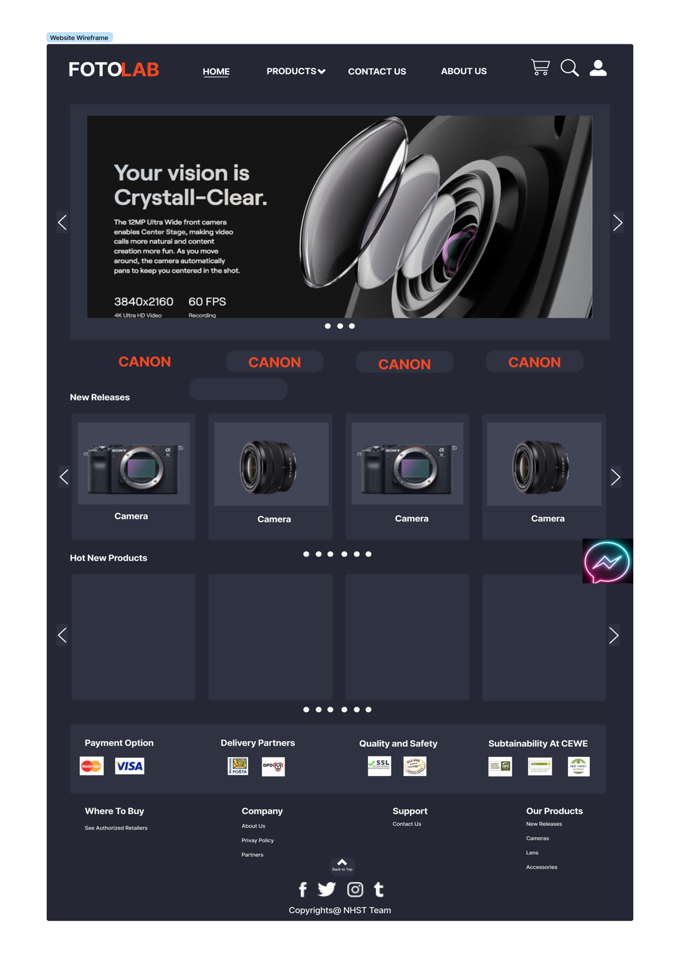

**Description:** This is a homepage of FotoLab, the top of this page is a header, after that is a navigation bar. The main part of a homepage beside the slider also includes 2 sections: New releases, best seller. The footer of a homepage has 2 sections: partnership, certifications, and link to other information pages or contact information.

### Sign in

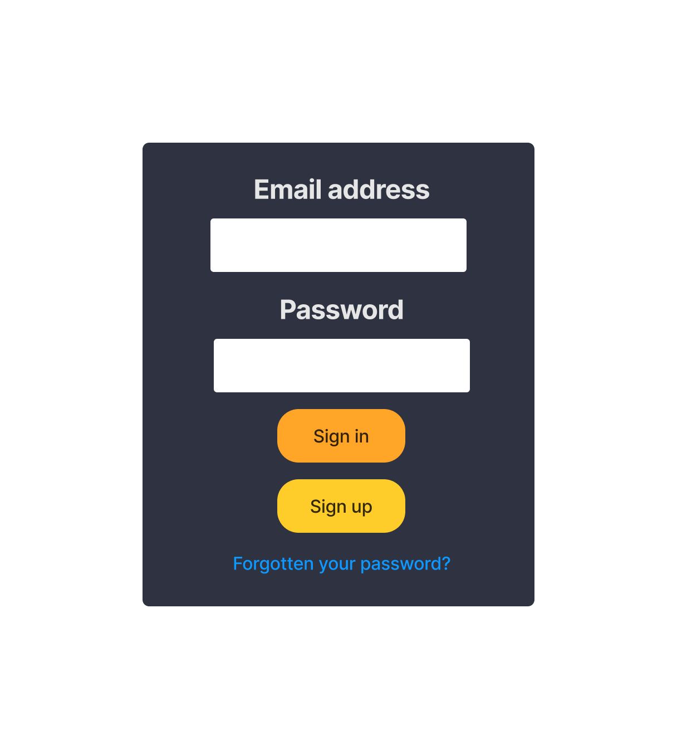

**Description:** When the user clicks on the human icon in the header, it pop-up a sign in window. This form requires the user to enter an Email address and a password. After clicking the login button, the user will be redirected to the homepage.

### Sign up

**Description:** If the user hasn’t created an account, he/she can click to Sign Up button and it will lead to this sign up page. This sign up form requires the user to enter 2 parts: personal data and login data. After clicking the Submit button the user will be redirected to the homepage.

### Product

**Description:** When the user clicks on the Product tag in the navigation. It will show list product: camera, lens, accessories. After choosing category The main part of a Product Page beside the slider also includes 4 sections: hot branch names, filter in the left of page, products, frame contain selected products for comparison.

### Product Comparison

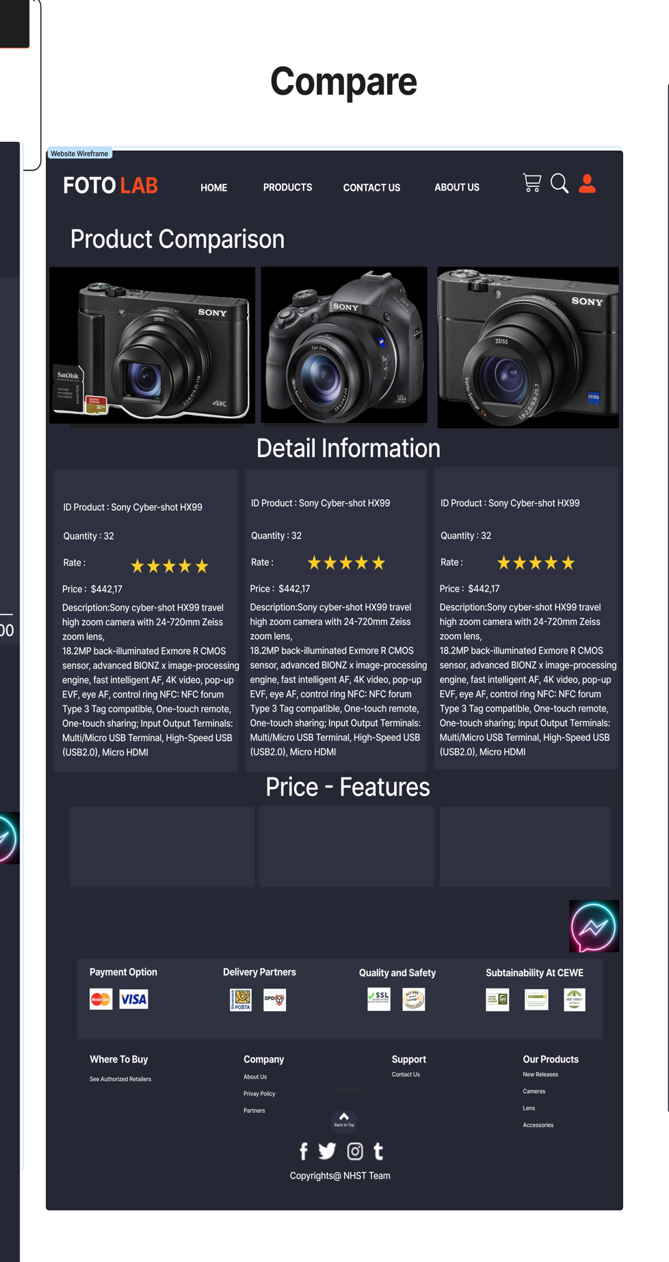

**Description:** When the user clicks on add icon on specific product, this product will be added to comparison, at least 2 items and less than 3 items can be compared. When the user clicks on compare button, it will lead to comparison page. This page show detail information of those items.

### Product Detail

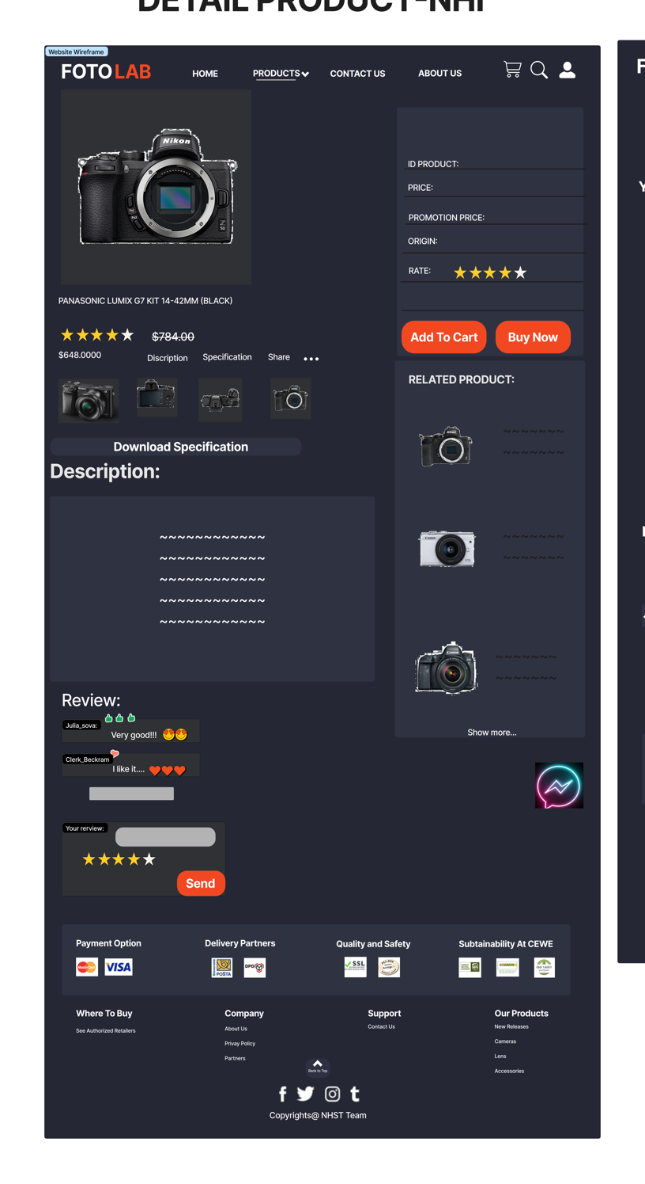

**Description:** When the user clicks on a specific product it will lead to this product detail page. Beside in detail information about the product, it also contains Buy Now and Add to Cart buttons. Moreover, it also contains the Reviews part, this includes reviews of the other buyers, and the user can write reviews about this product. The last part of this page is the Related Products section.

### Graphical user interface Description automatically generatedUser’s Cart

**Description:** When the user clicks on the cart icon in the header, the cart page will appear. It includes products that users have already added to cart, the user can select all items or remove items which they don’t have the intention to buy. The last part will be related products part.

### Buy Now Page

**Description:** After clicking the Accept button on the Cart or Buy now button in Product Detail Page, the user will be redirected to this checkout page. The left part of this page contains a form which requires the user to enter and the other side is the Order summary.

### Contact

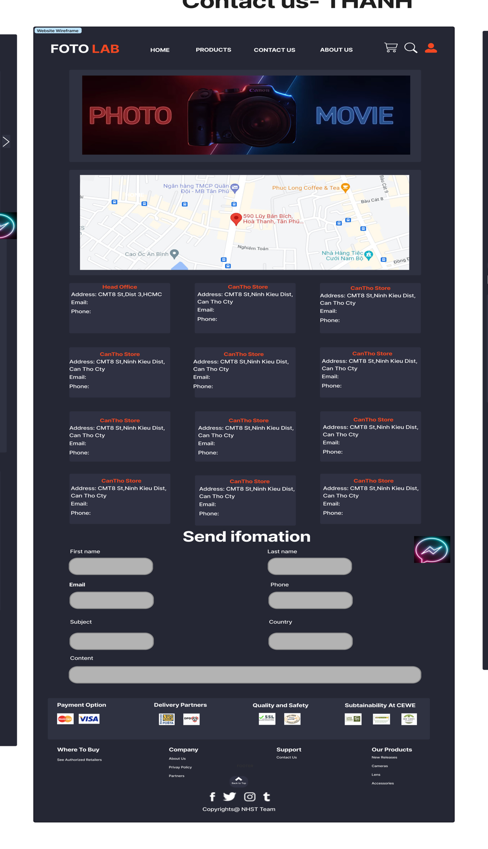

**Description:** After clicking the Contact tag on the navigation bar or Contact Us on the footer, the user will be redirected to this page. The first part of this page is a map, beside it is a detailed location of FotoLab’s Branches. The last part of this page is a Send information form to send their information to FotoLab.

### About Us

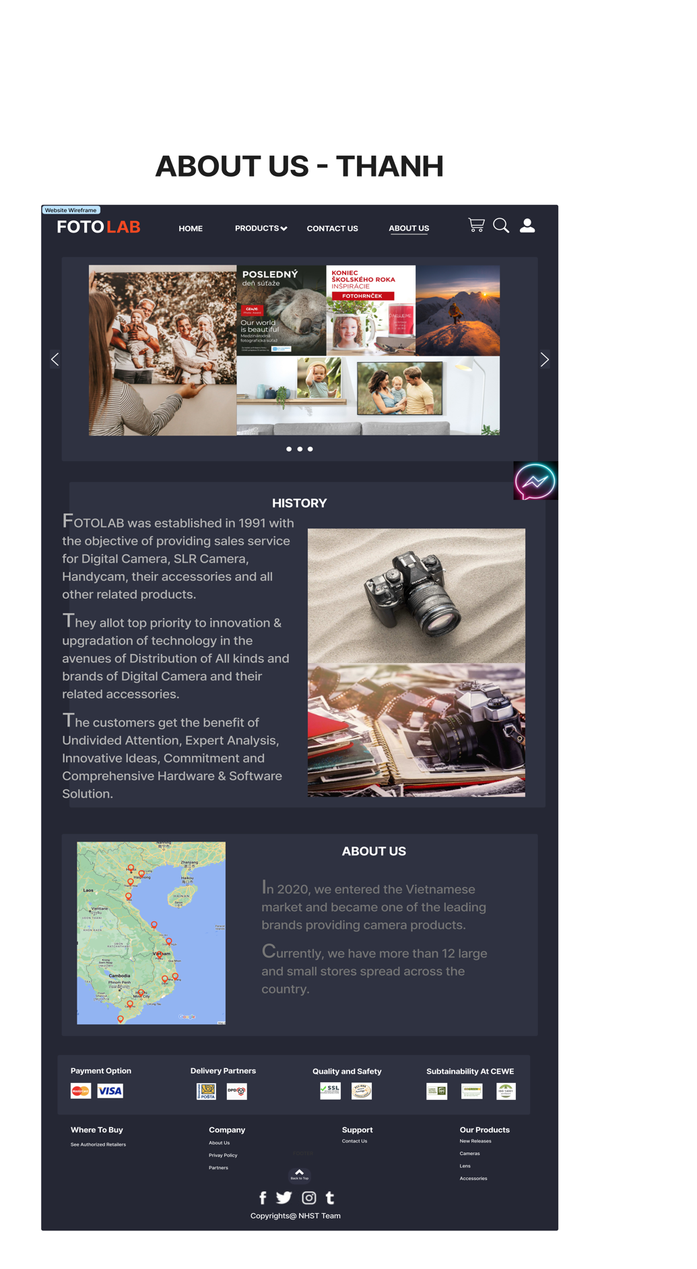

**Description:** After the user clicks on the About Us tag on the navigation bar or About Us tag on the footer , it will lead to this about this page. This page contains detailed information about FotoLab.

## Task Sheet

|  |  |  |  |  |  |  |
| --- | --- | --- | --- | --- | --- | --- |
| **Project Ref No.** | **Project Title – Ask Me Mobile** | **Activity Plan Prepared by** | **Date of preparation of Activity Plan** | | | |
| **Task** | **Actual Start Date** | **Actual Days** | **Teammate Names** | **Status** |
| Brainstorming ideas for layouts and Project Object | | Hiếu,  Nhi,  Sơn,  Thanh | 24/10/2022 | 1 days | Hiếu,  Nhi,  Sơn,  Thanh | Completed |
| Draw site maps and architecture design | | Hiếu,  Nhi,  Sơn,  Thanh | 25/10/2022 | 1 days | Hiếu,  Nhi,  Sơn,  Thanh | Completed |
| Wire framing general page layout | | Hiếu | 26/10/2022 | 2 days | Hiếu | Completed |
| Collect static assets (pictures, mp4, documentation,…) | | Hiếu,  Nhi,  Sơn,  Thanh | 26/10/2022 | 5 days | Hiếu,  Nhi,  Sơn,  Thanh | Incompleted |

# REVIEW 2

# WEBSITE USER INTERFACE

### Homepage

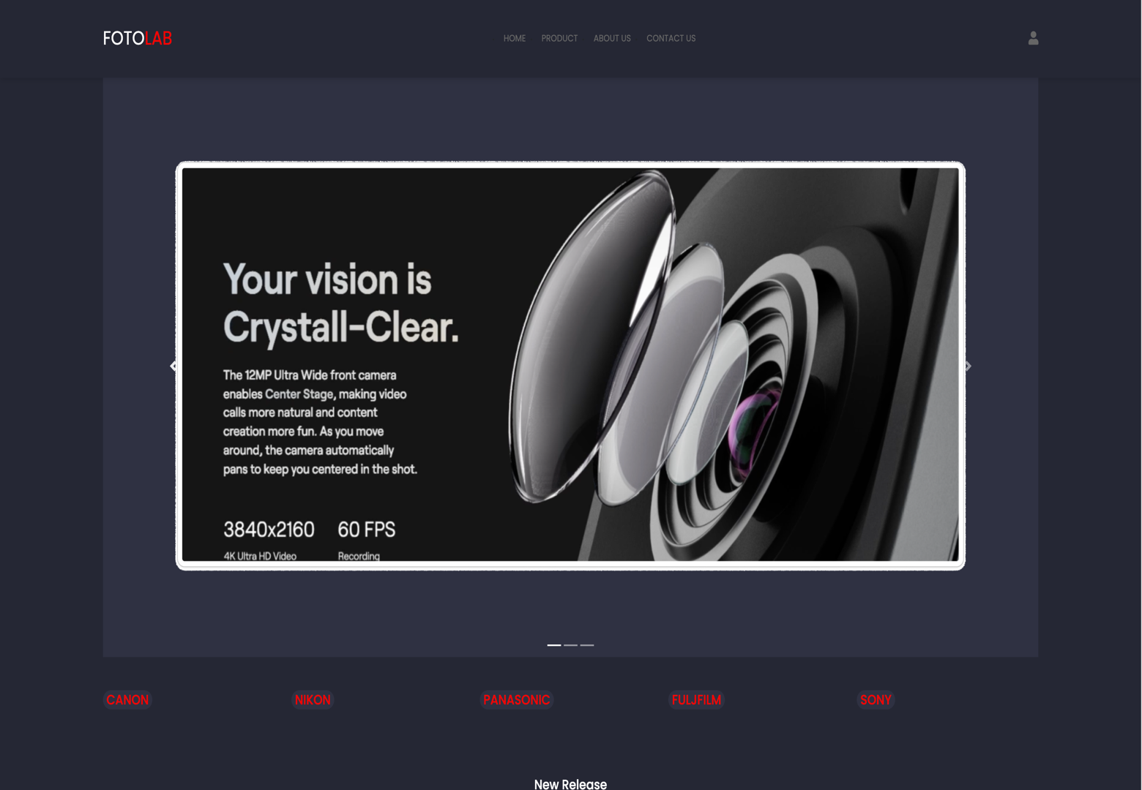

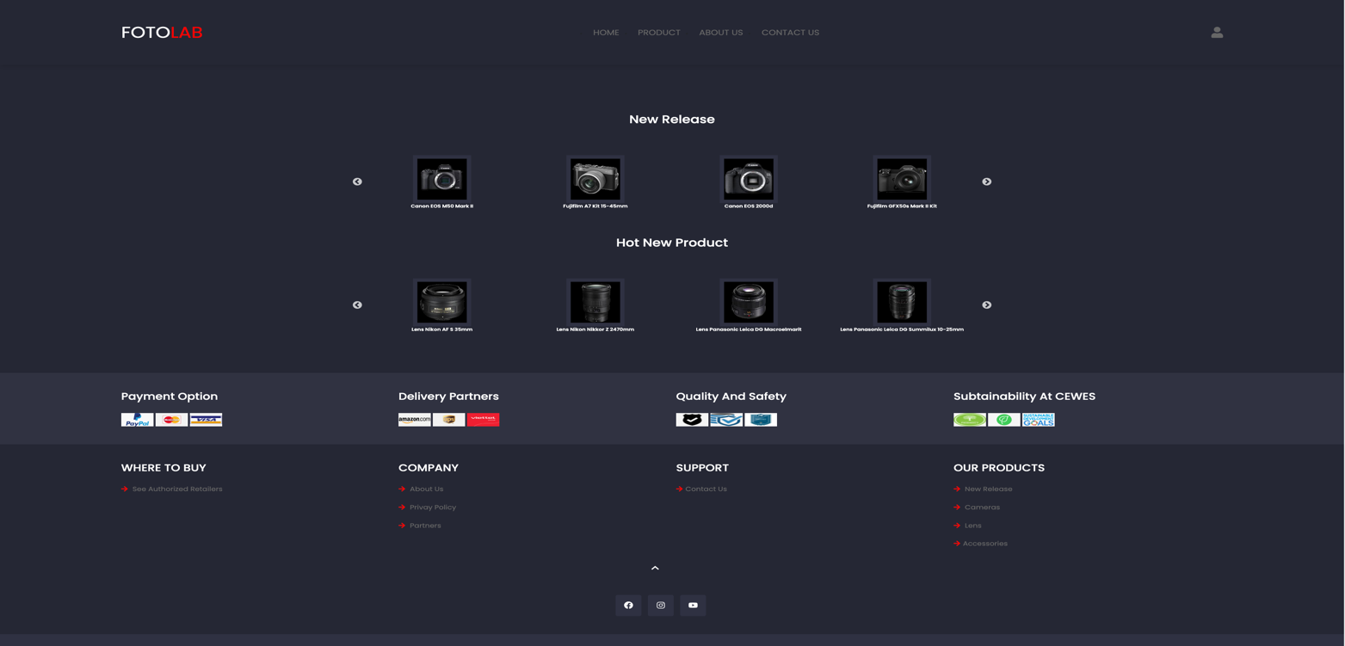

On navigation bar, User can click on our’s logo or “Home” tag to back Home Page; click on “Product” tag to go to Product Page; click on “About Us” to go to About Us Page; click on “Contact Us” to go to Contact Us Page. Beside that, user can Sign in/Sign up when you click on account icon on the right of top.

Below Navigation Bar, we have a carousel to present Hot Product/New Product’s Images and a lot of Branch’s names.

At main section, user can discover some new or hot product which we are selling by New Release/ Hot Product lists by clicking on product’s images.

At Footer, our website shows quality/safety certificates, delivery partners, payment options. Next that, there are “where to buy’, “company”, “support”, “our product” tag. Finally, it has links to access our facebook, Instagram and youtube page with “Back to Top” button.

### Sign In/ Sign Up dropdown

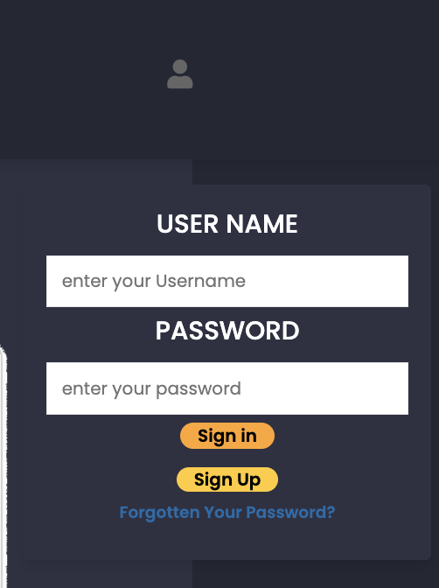

With Sign In/ Sign Up Tab, User can sign in your account (if having account) or click on “Sign Up” button to move to Register Page if user does not have account.

### Register Page

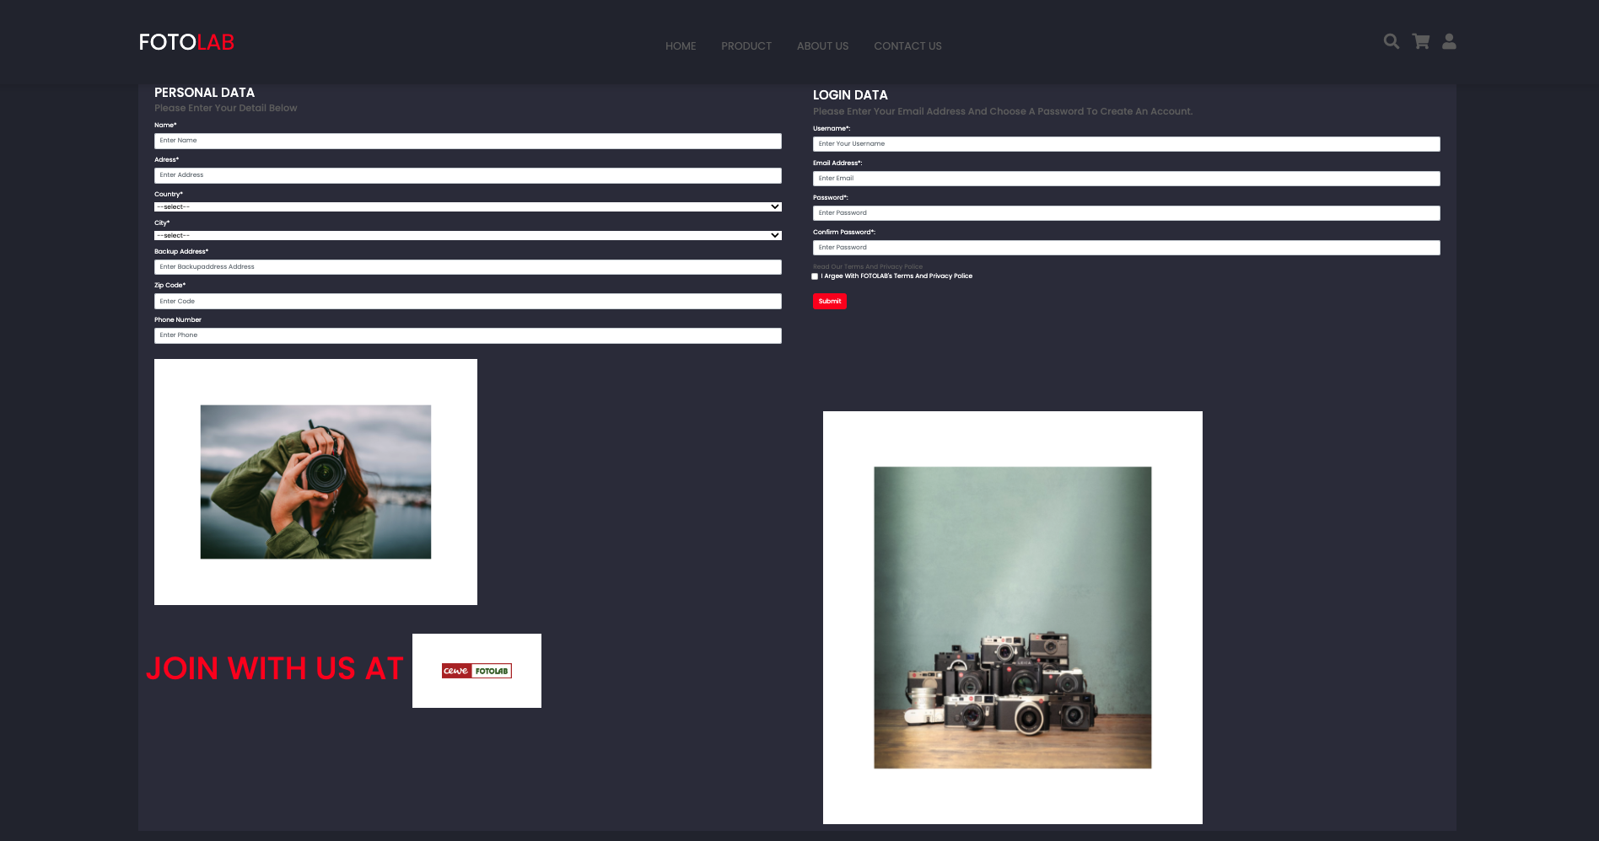

At Register Page, User has to fill user’s information – specially fields have star sign. If user does not fill all fields, user can not sign up. After sign up successfully, website will take user to back to Home Page.

### Product Page

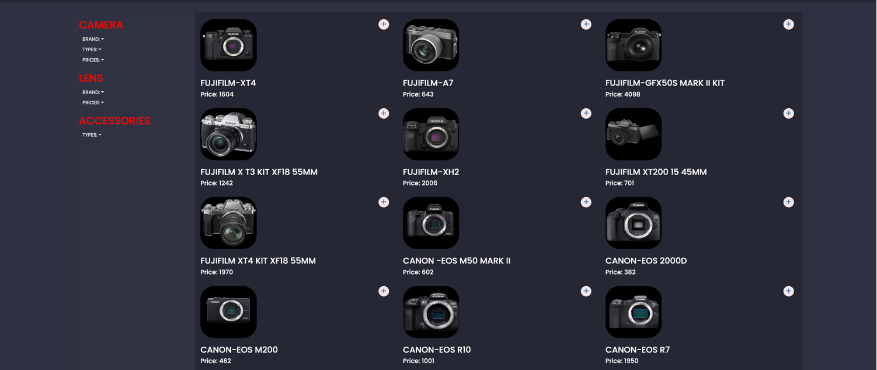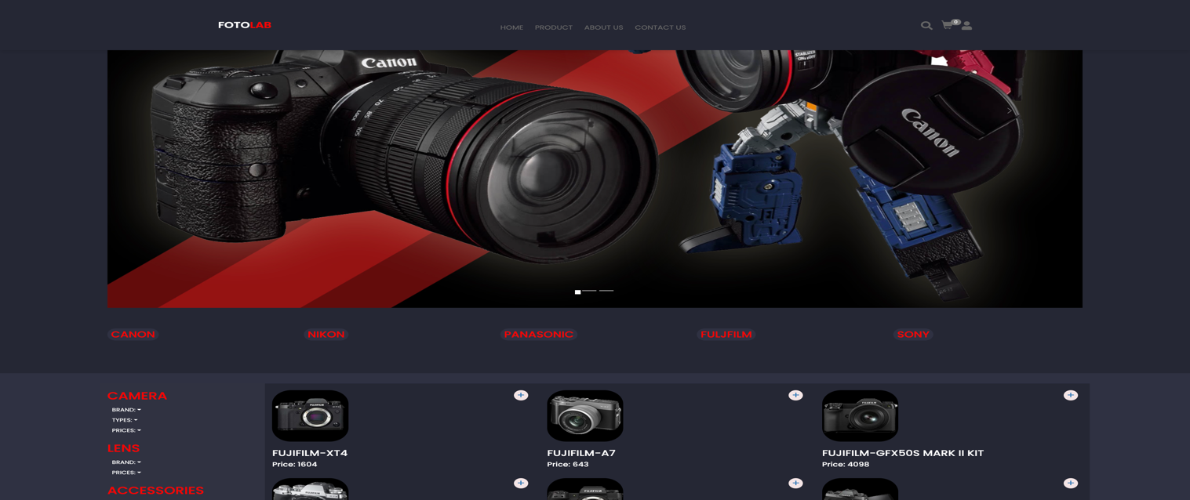

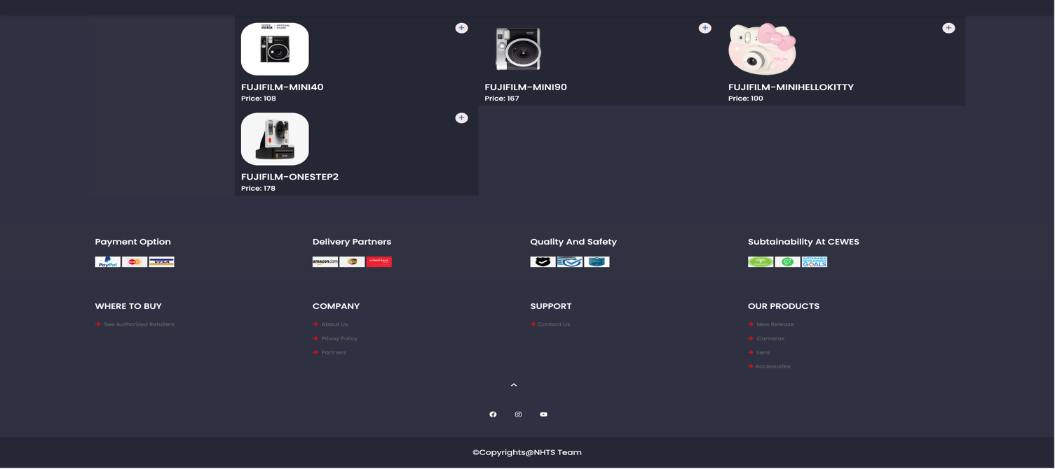

At Product Page, it shows all our product include cameras, lens and accessories. On each product, user can click on product image to access product detail or click on plus sign to add this product to comparison bar.

### Product Category/Search Dropdown

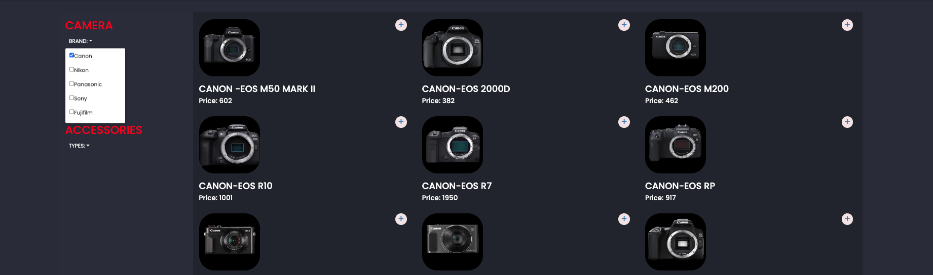

At Search Icon on the right of top, user can find product by product name.

With category bar on the left, user can sort product by types, branchs.

### Product Comparison

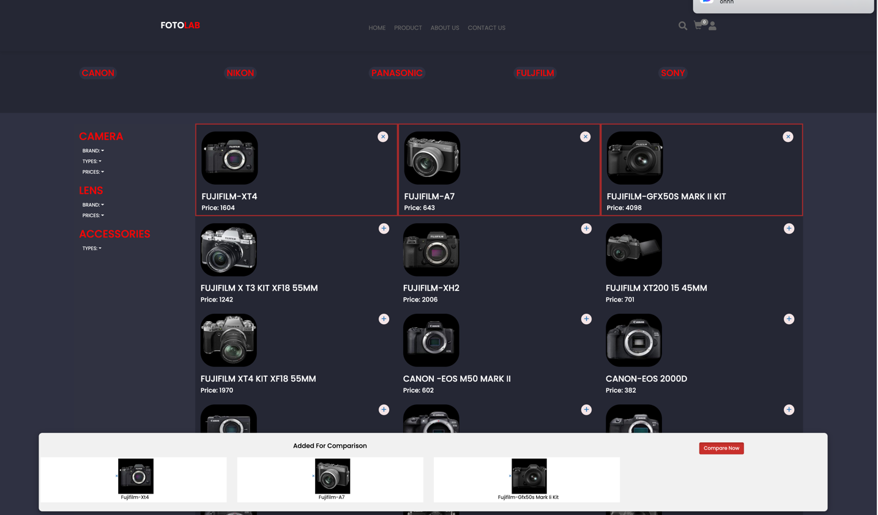

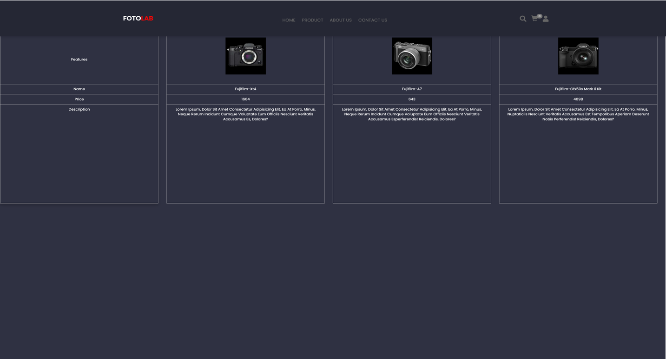

If user want to compare to products, user must choose minimum 2 product and 3 maximum. When above condition have been completed “compare now” button will be active to access.

### Product Detail

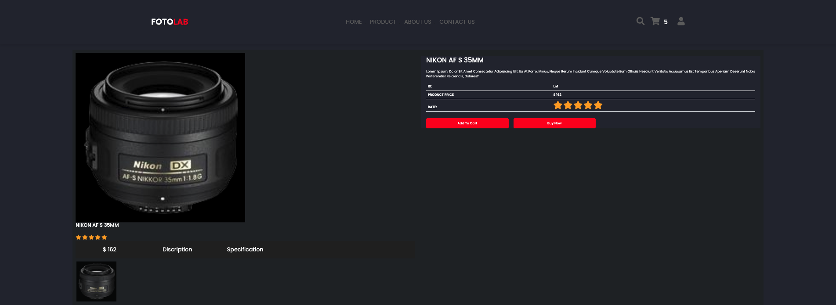

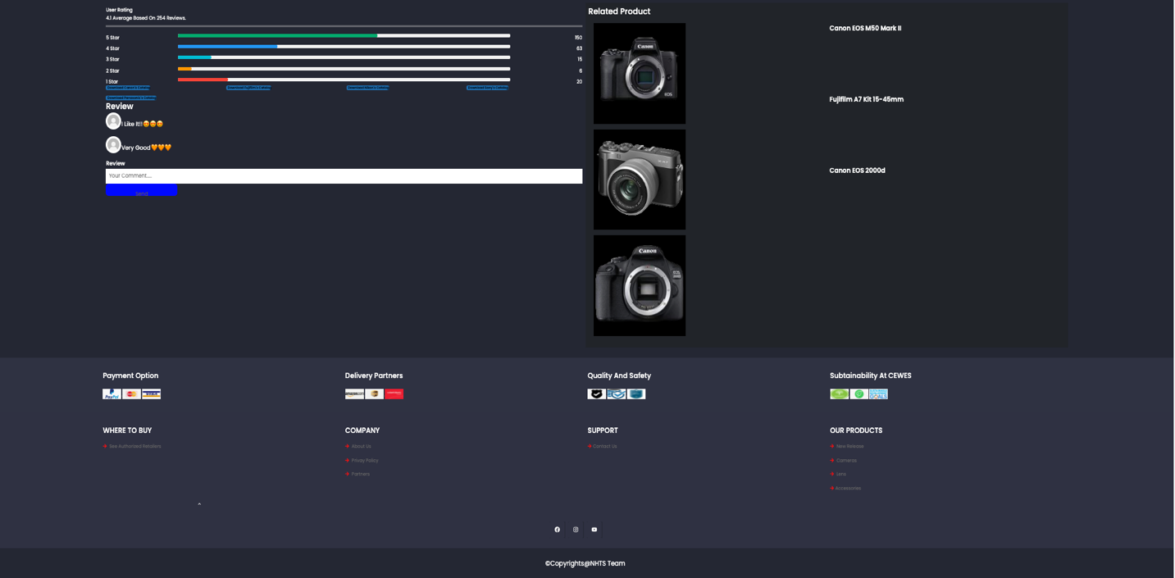

At Product Detail Page, User will be received full information about price, rating, description, some images and reviews of this product. At there, user can add this product to your cart by “Add to Cart” button, buy this product now by “Buy now” button or interact by commenting at review bar. Beside that, we alse provide some related product at Related product list next Review bar. Moveover, user can download catalogs about our product at “Download Brands’s Catalog” buttons.

### Cart Page

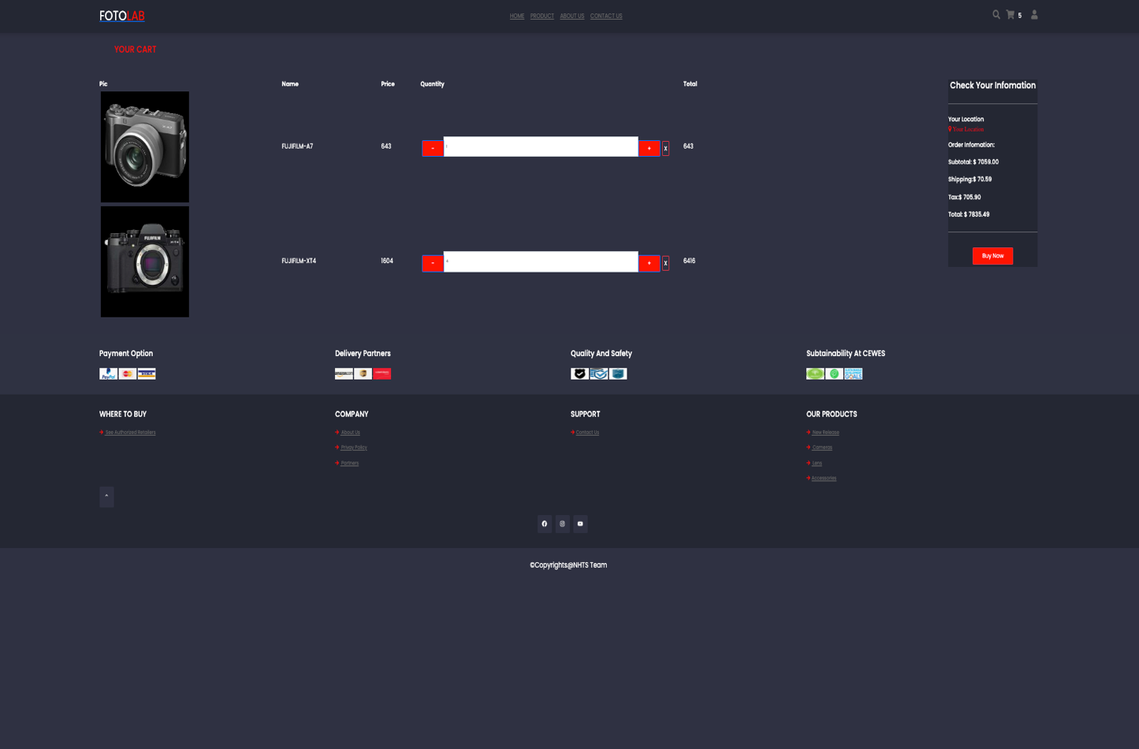

At Cart Page, user will see all products which user added. You can adjust quantity, delete product or check fees before paying.

After clicking on “Buy Now” button, user will be taken to Buy Now Page to paying.

### Buy Now Page

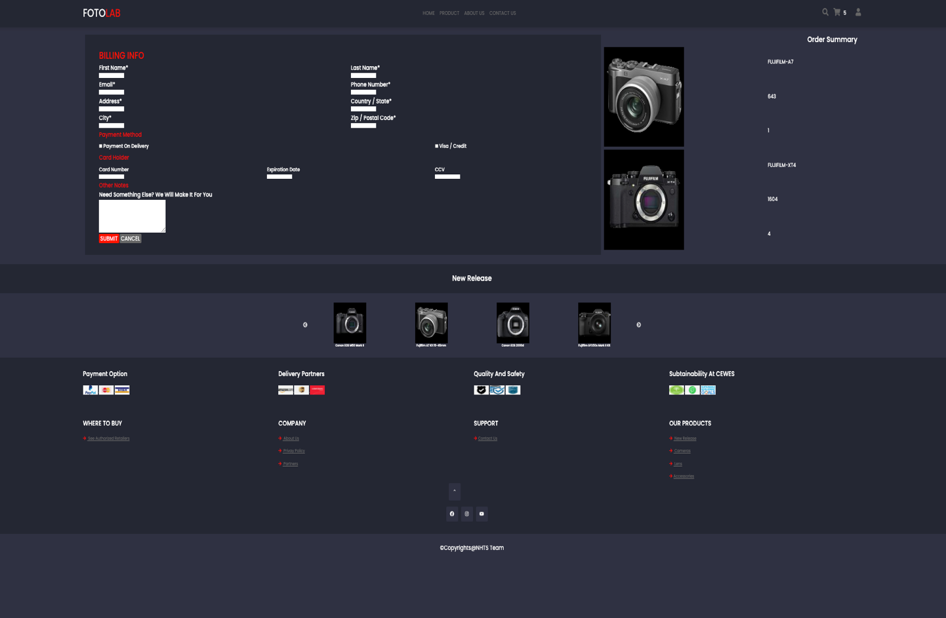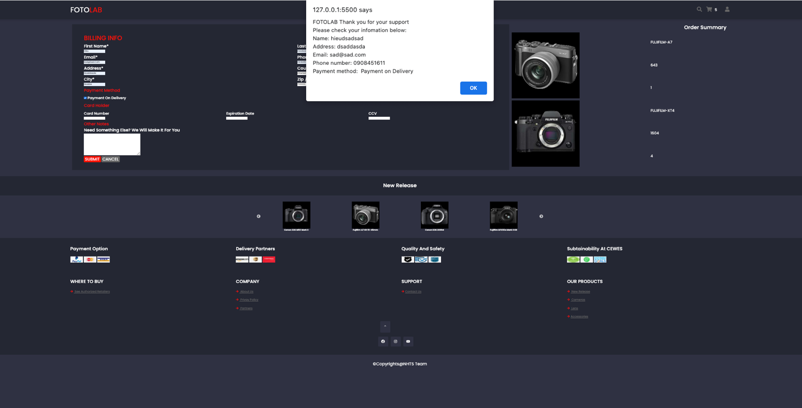

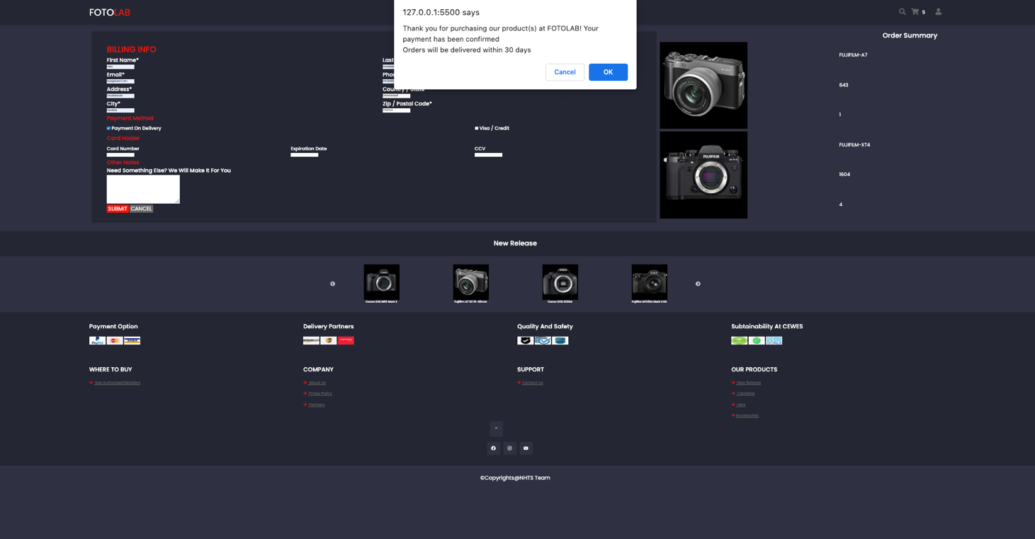

At Buy Now Page, User must fill user ‘s information included delivery info, paying info or some request if user need us to make them. After completing all fields, a alert will be appear with your filled information and confirmation that information. Finally user ordered successful.

### Contact

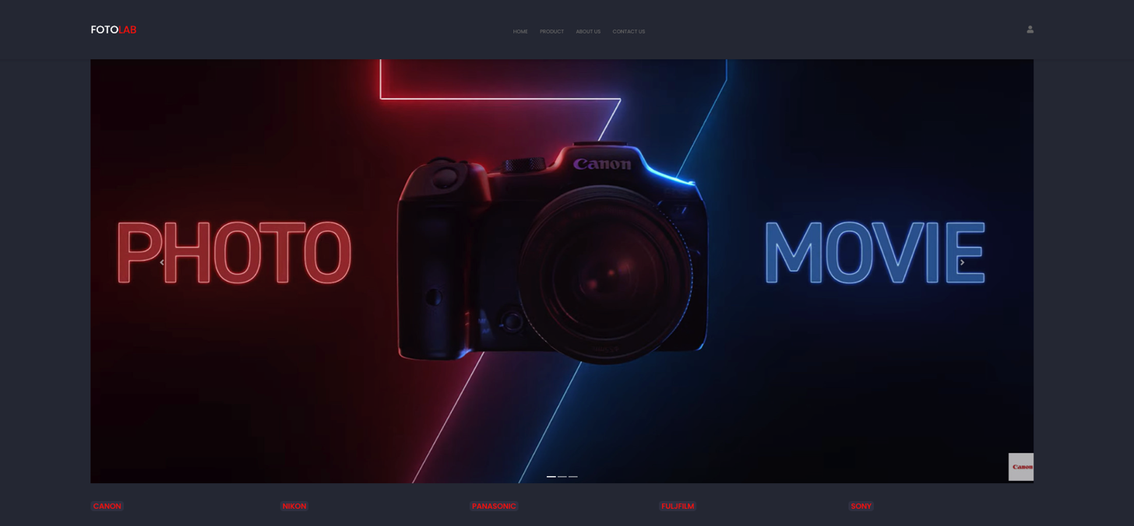

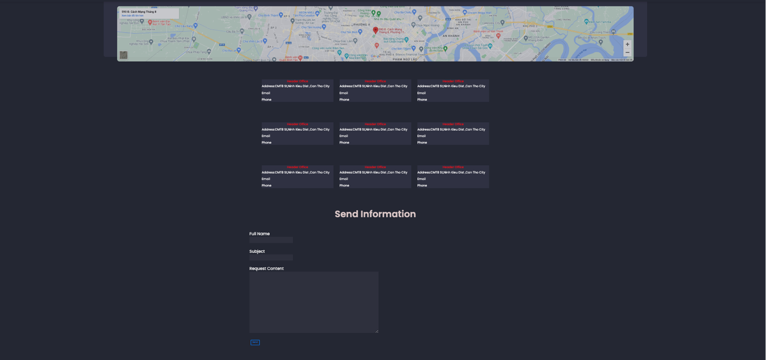

At Contact Us Page, website show the map of our head office and branches. User also can send email to us by Send Information part.

### About

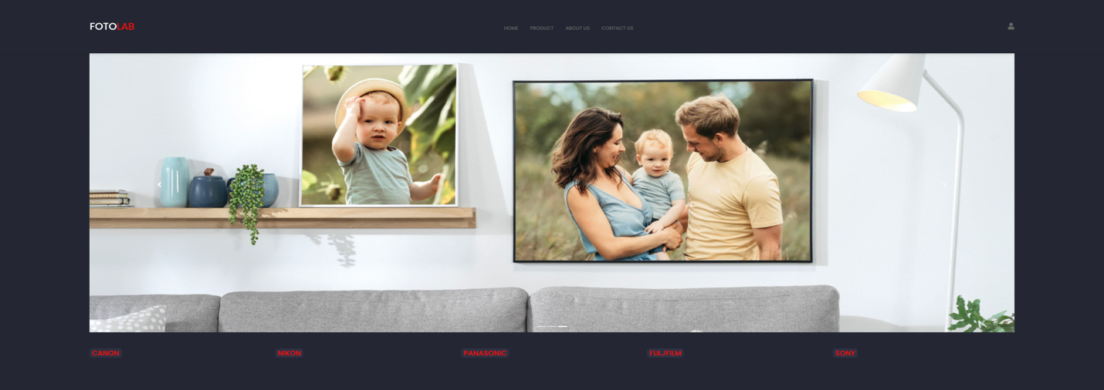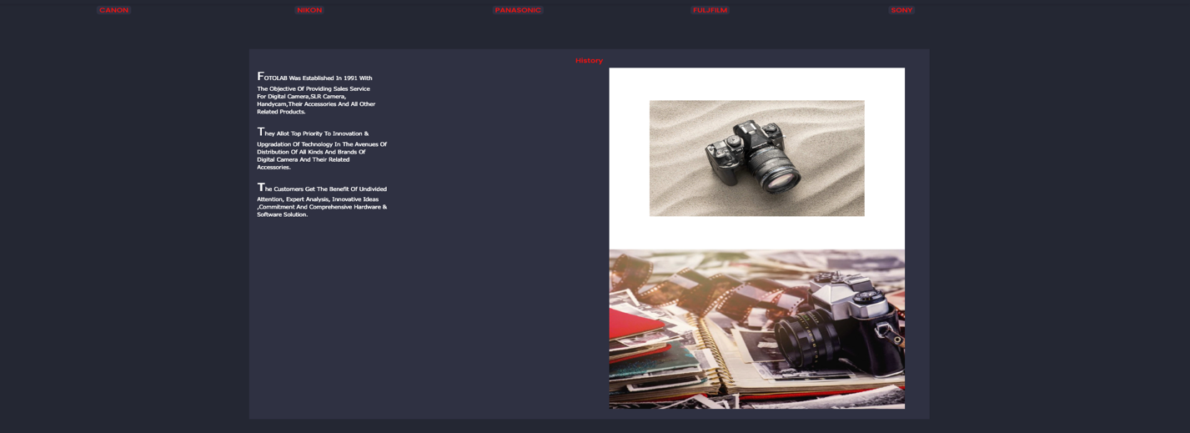

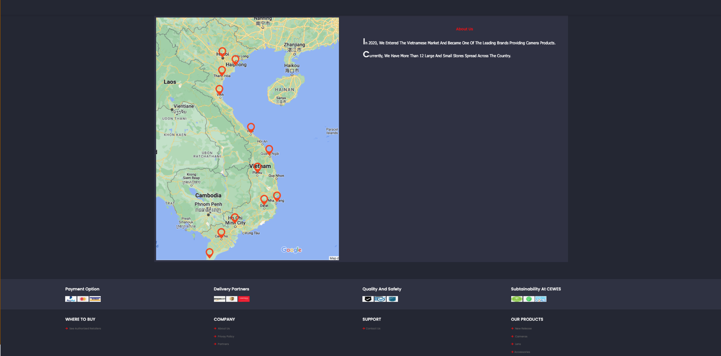

At About Us Page, website not only shows our histories, alocations and partners but also unveil our aims in future.

## Task Sheet

|  |  |  |  |  |  |  |
| --- | --- | --- | --- | --- | --- | --- |
| **Project Ref No.** | **Project Title – Ask Me Mobile** | **Activity Plan Prepared by** | **Date of preparation of Activity Plan** | | | |
| **Task** | **Actual Start Date** | **Actual Days** | **Teammate Names** | **Status** |
| Brainstorming ideas for layouts and Project Object | | Hiếu,  Nhi,  Sơn,  Thanh | 24/10/2022 | 1 days | Hiếu,  Nhi,  Sơn,  Thanh | Completed |
| Draw site maps and architecture design | | Hiếu,  Nhi,  Sơn,  Thanh | 25/10/2022 | 1 days | Hiếu,  Nhi,  Sơn,  Thanh | Completed |
| Wire framing general page layout | | Hiếu | 26/10/2022 | 2 days | Hiếu | Completed |
| Collect static assets (pictures, documentation,…) | | Hiếu,  Nhi,  Sơn,  Thanh | 26/10/2022 | 5 days | Hiếu,  Nhi,  Sơn,  Thanh | Completed |
| Design & Build Homepage | | Nhi,Hiếu | 27/10/2022 | 7 days | Nhi,Hiếu | Completed |
| Design & Build Sign in-Sign Up | | Nhi,Hiếu | 30/10/2022 | 1 days | Nhi,Hiếu | Completed |
| Design & Build Register | | Sơn,Hiếu | 27/10/2022 | 5 days | Sơn,Hiếu | Completed |
| Design & Build Product | | Hiếu,Nhi | 05/11/2022 | 7 days | Hiếu,Nhi | Completed |
| Design & Build Product Category/Search | | Nhi, Hiếu | 10/11/2022 | 5 days | Nhi, Hiếu | Completed |
| Design & Build Product Detail | | Hiếu Nhi | 13/11/2022 | 3 days | Hiếu Nhi | Completed |
| Design & Build Cart | | Hiếu,Nhi | 16/11/2022 | 2 days | Hiếu Nhi | Completed |
| Design & Build Buy Now | | Sơn,Nhi | 17/11/2022 | 2 days | Sơn,Nhi | Completed |
| Design & Build Contact | | Thanh,Hiếu | 16/11/2022 | 1 days | Thanh,Hiếu | Completed |
| Design & Build About | | Thanh,Hiếu | 18/11/2022 | 1 days | Thanh,Hiếu | Completed |
| Product Comparison | | Hiếu,Nhi | 18/11/2022 | 2 days | Hiếu,Nhi | Completed |
| Write Project Report | | Hiếu,Sơn | 20/11/2022 | 1 days | Hiếu,Sơn | Completed |

## Testing document

|  |  |  |  |  |
| --- | --- | --- | --- | --- |
| **Sr.No** | **Features Tested** | | | **Remarks** |
| 1 | Are all the users able to view the images and links? | | | OK |
| 2 | Have all the views, modules and controllers been | |  | OK |
| properly integrated and is the site function as a single | | |
| page application? | |  |
| 3 | Are the GUI content devoid of spelling mistakes? | | | OK |
| 4 | Is the application user-friendly? | | | OK |
| 5 | Is the Website launching correctly in all popular | |  | OK |
| browsers? |  |  |
| 6 | Are all the forms validated with proper criteria? | | | OK |
| 7 | Do all text links lead to the appropriate website? | | | OK |
| 8 | Do all image links lead to the appropriate website? | | | OK |
| 9 | Are all the images and links clearly visible on the page? | | | OK |
| 10 | Does the Web page work properly in all the tested | |  | OK |
| browsers? |  |  |
| 11 | Does the Web page take too long to be loaded fully? | | | OK |
| 12 | Is the navigation sequences correct through all the Web | | | OK |
| pages on the site? | |  |
| 13 | Is the JavaScript code working as expected in all click | | | OK |

## Final checklist

|  |  |  |  |  |
| --- | --- | --- | --- | --- |
| **Sr.No** | **Features Tested** | | | **Remarks** |
| 1 | Are all the users able to view the images and links? | | | OK |
| 2 | Have all the views, modules and controllers been | |  | OK |
| properly integrated and is the site function as a single | | |
| page application? | |  |
| 3 | Are the GUI content devoid of spelling mistakes? | | | OK |
| 4 | Is the application user-friendly? | | | OK |
| 5 | Is the Website launching correctly in all popular | |  | OK |
| browsers? |  |  |
| 6 | Are all the forms validated with proper criteria? | | | OK |
| 7 | Do all text links lead to the appropriate website? | | | OK |
| 8 | Do all image links lead to the appropriate website? | | | OK |
| 9 | Are all the images and links clearly visible on the page? | | | OK |
| 10 | Does the Web page work properly in all the tested | |  | OK |
| browsers? |  |  |
| 11 | Does the Web page take too long to be loaded fully? | | | OK |
| 12 | Is the navigation sequences correct through all the Web | | | OK |
| pages on the site? | |  |
| 13 | Is the JavaScript code working as expected in all click | | | OK |